# Permission Overrides

**Allow Gods:** God mode is available to selected people if enabled.   These levels can be set for individual users in the Web control panel.

·         Level = 0 is a normal user

·         Level = 50 (or a level you set) is used to indicate a privileged user (e.g. who can set up new Hypergrid linked regions)

·         Level = 100 is a Wifi admin account user

·         Level >= 200 can become a God

**Estate Owner is God:** If enabled, the region owner may go into God mode.

**Estate Manager is God:** If enabled, any region estate manager may go into God mode.

**Permissions**

Grid god mode allows certain users to take and control permissions over objects. Setting Grid God Mode on allows you to control individual users by editing their access level in the Wifi Users Panel. Any user with a level > 100 will be a grid god. You can set any estate owner or estate manager to be a grid god, too. Users can become Gods by using the Request Admin Level button in the Advanced Viewer menu.

God mode is a useful function. However, making copies of items that are no copy or no transfer and giving them to others could be illegal. Please remember that copyright laws for your country need to be respected.

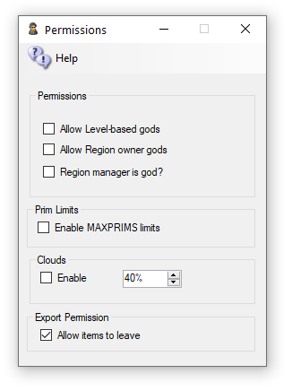

**Allow Gods:** God mode is available to selected people if enabled. These levels can be set for individual users in the Web control panel.

1. Level = 0 is a normal user
2. Level = 50 (or a level you set) is used to indicate a privileged user (e.g. who can set up new Hypergrid linked regions)
3. Level = 100 is a Wifi admin account user
4. Level >= 200 can become a God

**Estate Owner is God:** If enabled, the region owner may go into God mode.

**Estate Manager is God:** If enabled, any region estate manager may go into God mode.

**Prim Limits:** Opensimulator normally does not enforce limits on the number of prims for a region or a parcel. The viewer can show a maximum of 45,000 prims.

You can lower or raise any region limit in the Regions Control panel.

Default: Unchecked

**Clouds**: The original particle clouds from the early days of Second Life are still available for older viewers such as Singularity.

Default: Checked

**Export:** Export Checkbox can disallow export of prims by a viewer. Default -> Allow

# Physics Overrides

1. ODE is a very old physics engine with many limitations. It does support Ninja Physics.
2. UBODE is closer to Second Life in vehicle performance.
3. Both BulletSim and UBODE support varregions.
4. BulletSim provides the best performance and most functionality.
5. Bullet in a separate thread prevents physics crashes from crashing the region. It is the default physics engine.
6. ODE Ninja physics are documented in another manual

Physics Engine

The Physics selection box lets you set basic physics, where the only collidable object is a box shape. It supports the original Open Dynamic Engine physics. The **ubODE** engine, by Ubit Umarov, is an advanced version of ODE that is closer to Second Life compatibility with vehicles.  Bullet is an award-winning physics engine.

1. ODE is a very old physics engine with many limitations. It does support Ninja Physics.
2. UBODE is closer to Second Life in vehicle performance.
3. Both BulletSim and UBODE support varregions.
4. BulletSim provides the best performance and most functionality.
5. Bullet in a separate thread prevents physics crashes from crashing the region. It is the default physics engine.
6. ODE Ninja physics are documented in another manual.

Links:

<http://www.ode.org/>

<https://en.wikipedia.org/wiki/Bullet_(software)>